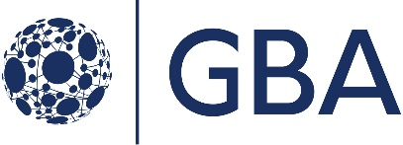

Government Blockchain Association

The GBA Distributed Autonomous Organization (DAO) Whitepaper

DRAFT 0.4

September 11, 2020

Contents

1. Introduction 1
   1. Purpose 1
   2. Scope 1
   3. Terms & Definitions 1
      1. Decentralized Autonomous Organization (DAO) 1
   4. Motivation – Why Build a DAO? 1
   5. What Will the GBA DAO Do? 2
   6. How Does the GBA DAO Work? 3
2. DAO Governance 3
   1. Development 3
   2. Maintenance 4
3. DAO Process 4
   1. Submission 4
   2. Voting 4
      1. Acquiring Voting Tokens 5
      2. Casting Votes 5
      3. Determining Outcome 5
      4. Determining Token Amount for a Proposal 5
   3. Implementation 6
      1. Phase I: Ignite 6
      2. Phase II: Design 7
      3. Phase III: Align 7
      4. Technology Architecture 8
4. Legal Analysis 8
   1. Howey Test - Security Analysis 9
      1. Legal Requirement 9

Appendix A – Glossary 11

Disclaimers

This document has not been reviewed or approved by the GBA Leadership Team. It is a concept paper and does not reflect any formal decision made by the organization. It is intended to define a proposal that will be submitted, reviewed, and if accepted, approved. As of this point, it a proposal.

References and Related Documents

* GBA Token White Paper
* GBA Member DAO Phase 1 Concept paper, 3/18/2020 (Max Gravitt)

# Introduction

## Purpose

This document describes the motivation, strategy, benefits, risks, mitigations, and plan for the GBA to launch a Distributed Autonomous Organization (DAO)[1].

## Scope

This document applies to the work being performed by the GBA Governance – DAO Working Group to create the distributed software system that enables GBA members to contribute to the GBA, make decisions, and benefit from those decisions. It is intended to function within the boundary and scope of the laws of the United States, the Commonwealth of Virginia, and the Bylaws published by the GBA.

## Terms & Definitions

The glossary in Appendix A contains a full set of term and definitions. However, the listing below includes the critical terms needed to establish a context for this whitepaper.

### Decentralized Autonomous Organization (DAO)

A decentralized autonomous organization (DAO), sometimes labeled a decentralized autonomous corporation (DAC), is an organization represented by rules encoded as a computer program that is transparent, controlled by the organization members, and not influenced by a central government. A DAO's financial transaction record and program rules are maintained on a blockchain. The precise legal status of this type of business organization is unclear[2].

Additional information about DAOs is described in the report, [The State of Blockchain Governance](https://drive.google.com/file/d/1FB4K-xprvRsPTpKQIQ-Y5P3OB7aGCJBu/view)[3].

## Motivation – Why Build a DAO?

The first paragraph on the Government Blockchain Association (GBA) website states:

“*Government Blockchain Association (GBA) promotes blockchain technologies by empowering individuals and organizations to connect, communicate, and collaborate to solve public sector challenges around the world.”*

One of the biggest public sector challenges faced by governments around the world is a loss of public trust. Blockchain technology can facilitate solutions to this challenge.

Smart contracts can be highly effective to promote government processes with trust and integrity. However, smart contracts by themselves will not solve the problems. The smart contracts must be connected to organizations and decisions in an ecosystem that enables decisions to be made in a transparent, fair, and trustworthy manner. A Distributed Autonomous Organization (DAO) establishes the ecosystem for the smart contracts to interoperate.

DAOs have a wide array of potential benefits and uses. They include:

* **Cooperatives** - DAOs enable a group of people to decide on the allocation of resources and priorities. Trust in the transparency and execution of the reached agreement is backed by the immutability of blockchain.
* **Aid allocation** - Governments and not-for-profit organizations struggle to allocate funds in a transparent and effective way. Multi-signature, auditability and automatically enforced resource agreements significantly lower the risk of misuse of funds and opaque decisions.
* **Government Applications** - Issuance and tracking permits, certificates records or registries are key functions of regulators. DAOs leverage the trust possible with blockchain while allowing for issuance and revocation workflows that are efficient and transparent.
* **Start-ups** - DAOs enable raising capital and providing ownership or visibility. This functionality can be used by traditional start-ups launching products or services. Not-for-profit focused on clean water, community help etc. They can also be used to raise funds.

However, the technology, economics, regulatory, and other aspects of this technology are still very immature and undefined. GBA has an opportunity to develop the tools, technologies, and methods to become leaders in this space. Building a DAO and working through the uncertainties allow GBA to provide value to members. Ultimately it allows GBA to promote blockchain technologies by empowering individuals and organizations to connect, communicate, and collaborate to solve public sector challenges around the world.

## What Will the GBA DAO Do?

The GBA DAO will be used by GBA groups to propose, decide, and manage GBA work. Some examples include:

* GBA members may propose a project to be worked on by members of the working group to adopt and deliver. The DAO could be used to determine who will work on the project, and how the outputs will be distributed.
* Project sponsors may donate tokens for a project or task. People could apply to perform the project or task. And, when accepted and completed, the DAO will distribute the tokens to the people that complete the project or task.
* The DAO could be used to support elections of GBA leaders in accordance with the GBA Bylaws. These positions could include chapter leaders, community group leaders, working group leaders, GBA operational staff, and GBA Board Members.

The GBA DAO will also be used to manage the supply and distribution of the GBA Tokens. The GBA Token Whitepaper describes the tokens issued by the GBA. These include a Voting Token, a Reward Token, and a Utility Token. The DAO will be the primary mechanism to determine the quantity of tokens distributed and the recipient of the tokens.

## How Does the GBA DAO Work?

The DAO is software that runs on a blockchain. It allows members of the DAO to contribute Utility Tokens, Voting Tokens, Reward Tokens, and cryptocurrency to the DAO. The members of the DAO propose rules to the community of DAO members. Those rules are reviewed and voted on. Based on the results of the outcomes, the rules are adopted and incorporated into the DAO.

GBA members also may propose projects to the DAO. Those projects may be approved and assigned based on the agreed rules. Completion of the projects or tasks may result in the distribution of tokens as per the DAO rules.

# DAO Governance

## Development

The idea of using a blockchain with the GBA (and perhaps as a DAO) pre-dates the existence of the DAO working group. In early 2020, [Max Gravitt](https://www.gbaglobal.org/members/digital-scarcity/profile) was asked to lead the working group to accomplish two goals:

* Develop a DAO ‘toolkit’ with technology and playbooks/guides to enable anyone to launch their own DAO
* Start a DAO for the GBA

The working group was announced in March and started holding regular weekly meetings in April. The work to build, test, and launch the DAO is being performed by volunteers. The volunteers and rest of the working group believe that GBA is well positioned to design, develop, build and manage the set of best practices and technology toolkit for blockchain applications, particularly applications related to governance.

Development of the DAO for GBA is ‘feature complete’ and has been deployed to a test network and main network, although the main net has not been activated.

Testnet: <https://dev.gbadao.com>

Mainnet: <https://gbadao.com>

## Maintenance

The DAO is intended to be self-maintaining. Only GBA members may join the DAO. GBA Reward Tokens may be minted and distributed to individuals contributing to the DAO based on corresponding votes.. The amount, and type of tokens will be determined by the DAO. The GBA Reward Tokens may be exchanged for GBA memberships, training, conferences, and other items of value within the GBA community. The GBA Reward Tokens may also be exchanged in a peer-to-peer transaction with other GBA Token Wallet holders.

The GBA DAO members will propose work to be done, determine the number of tokens to be awarded for the work, determine who will perform the work, and release the tokens once the work has been performed.

# DAO Process

## Submission

Any GBA member may submit a proposal to the DAO. Each proposal includes the following inputs:

* 1. Proposal Title
  2. Proposal Description
  3. Token Recipient
  4. Quantity of Voting Tokens (GBAV) to be issued to recipient if proposal passes
  5. Quantity of Reward Tokens (GBAR) to be issued to recipient if proposal passes

Token quantities are not required. For example, proposals can contain policies or just human-readable text for members to vote on. A proposal may be created for changing how voting works; it would first be voted on as text and then later the actual code upgrade would be voted on (at first, the multisig tech team can approve the code) to be deployed.

## Voting

Voting is the process by which the DAO makes decisions and takes actions.

### Acquiring Voting Tokens

At genesis, each qualifying member (is this the 21 electors, the DAO/gov/crypto working groups, both?) receives 1 voting token (GBAV). All subsequent voting issuance will occur if and only if proposals indicating so are passed.

*(Max NOTE: We can do this, but it's not currently implemented.)*: Each active GBA member receives one Voting Token per month. They may also exchange earned Reward Tokens for an equal amount of Voting Tokens.

### Casting Votes

Any member may vote PASS, FAIL, or ABSTAIN on any proposal. When a member submits one of these votes, their entire GBAV quantity (a.k.a. "voting power") is assigned to their selected vote.

*(Max NOTE: We can do this, but it's not currently implemented.):* The DAO members may spend their Voting Tokens on any submitted proposal. Voting power is scaled so that no single voter may have more than a 1% impact on the voting results. The Voting Tokens are burned as they are cast.

### Determining Outcome

For a proposal to be dispositioned and the outcome determined, at least 20% of the quantity of GBAV tokens must be cast. Greater than 50% of voting power must vote in favor of the proposal for it to pass. The initial quorum and approval thresholds may be modified by the DAO at any point after the initial launch.

### Determining Token Amount for a Proposal

All token quantities are defined when the proposal is created by the member.

*(Max NOTE: We can do this, but it's not currently implemented) I do like the approach below, but it is a bit complex and harder for members to understand. One of the biggest challenges is educating members on how voting works, so I recommend keeping it as simple as possible for genesis. The simple PASS /FAIL fits a well understood mental model. Then, we can let the will of the voters modify how proposals work and implement something like the below.)*

Members voting on a proposal will consider the total tokens available to be allocated to proposals, and assign a number of tokens to the proposal out of that total based on predefined proposal evaluation criteria. The proposal submitter will receive the average number of tokens assigned during the voting process.

## Implementation

The implementation will take place in three phases. They are:

* Phase I: Ignite
* Phase II: Design
* Phase III: Align

The diagram below illustrates the three phases and the text below the diagram provides additional context and information about each phase.

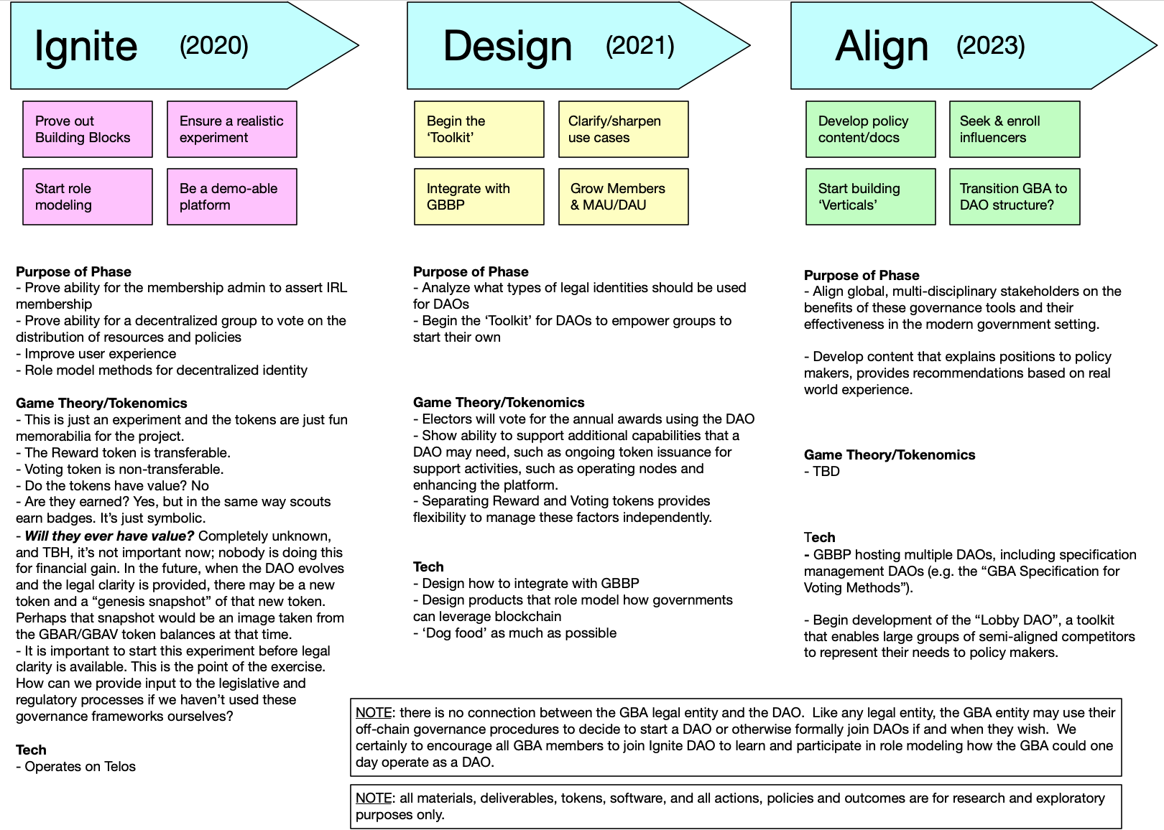

### Phase I: Ignite

#### Purpose of Phase

* Prove ability for the membership admin to assert IRL membership
* Prove ability for a decentralized group to vote on the distribution of resources and policies
* Improve user experience
* Role model methods for decentralized identity

#### Game Theory/ Tokenomics

This is just an experiment and the tokens are just fun memorabilia for the project.

* The Reward Token is transferable.
* Voting Token is non-transferable.
* Do the tokens have value? No
* Are they earned? Yes, but in the same way scouts earn badges. It’s just symbolic.

#### Tech

* Operates on Telos

### Phase II: Design

#### Purpose of Phase

* Analyze what types of legal identities should be used for DAOs
* Begin the ‘Toolkit’ for DAOs to empower groups to start their own

#### Game Theory/Tokenomics

* Electors will vote for the annual awards using the DAO
* Show ability to support additional capabilities that a DAO may need, such as ongoing token issuance for support activities, such as operating nodes and enhancing the platform.
* Separating Reward and Voting Tokens provides flexibility to manage these factors independently.

#### Tech

* Design how to integrate with GBBP
* Design products that role model how governments can leverage blockchain
* ‘Dog food’ as much as possible

### Phase III: Align

#### Purpose of Phase

* Align global, multi-disciplinary stakeholders on the benefits of these governance tools and their effectiveness in the modern government setting.
* Develop content that explains positions to policy makers, provides recommendations based on real world experience.

#### Game Theory/Tokenomics

* Game theory/tokenomics to be determined.

#### Tech

* GBBP hosting multiple DAOs, including specification management DAOs (e.g. the “GBA Specification for Voting Methods”).
* Begin development of the “Lobby DAO”, a toolkit that enables large groups of semi-aligned competitors to represent their needs to policy makers.

### Technology Architecture

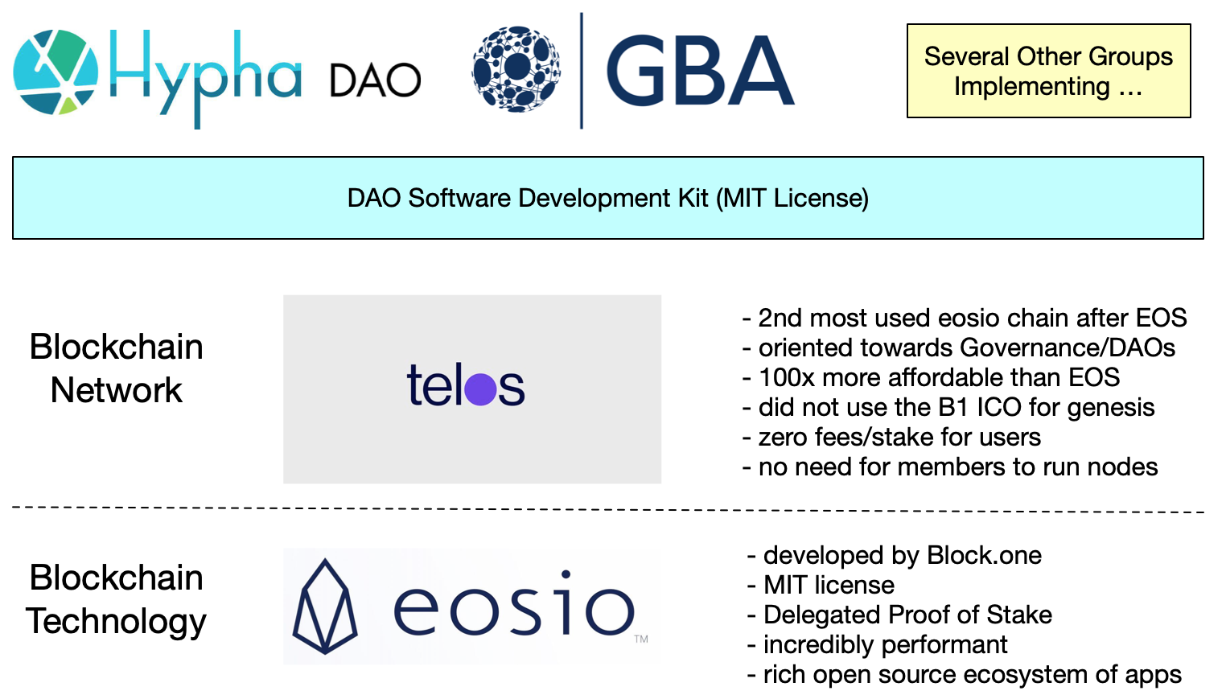

# Legal Analysis

It is undeniable that the legal and regulatory environment for Distributed Autonomous Organizations is unclear. That is an understatement to say the least. However, that reality results in two diametrically opposed responses. They are

* Stop! – The future is unknown. There is too much risk. Or,
* Go! – Leaders are needed to blaze a trail for others to follow.

The GBA is an industry leader. Leaders do not sit on the sidelines and wait for others to figure it out. Leaders charge into the unknown and make a way for others to follow.

While the legal analysis below is a good start, it will never be complete without the experience of someone working through these legal issues.

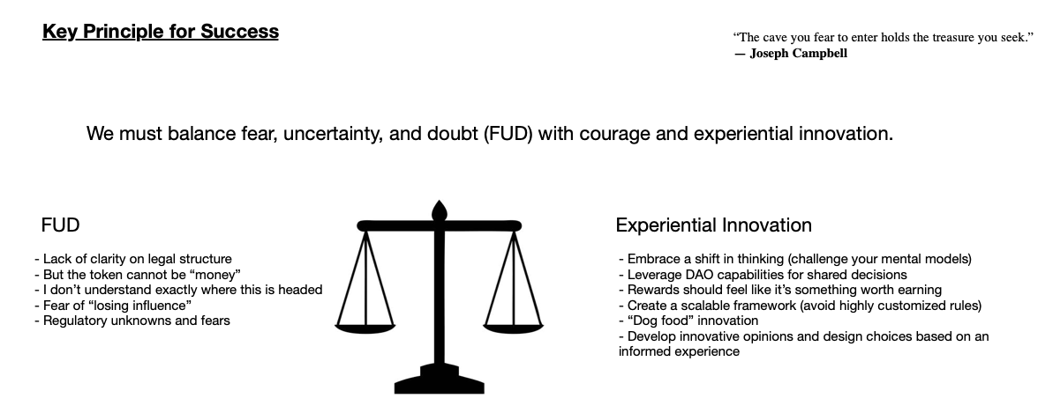

The Utah Law Review article, [Cryptocorporations: A Proposal for Legitimizing DAOs, 2019](https://dc.law.utah.edu/cgi/viewcontent.cgi?article=1244&context=ulr)[4] provides a legal analysis on the subject of DAOs. And provides insight into the legal issues related to this project.

Additionally, the working group has done an initial analysis of what we believe may be the legal issues related to the project. However, **these are not qualified legal opinions**. They are a summary of informal discussions by people knowledgeable about the topics. But, not qualified to provide formal legal counsel.

## Howey Test - Security Analysis

### Legal Requirement

The Howey Test asks whether the value of a transaction for one of its participants is dependent upon the other's work. Specifically, the Howey Test determines that a transaction [represents an investment contract if](https://medium.com/bittrust/passing-the-howey-test-how-to-regulate-blockchain-tokens-d218da93a8b6) "a person invests his money in a common enterprise and is led to expect profits solely from the efforts of the promoter or a third party".[5]

#### Response

Since we are not soliciting funds for the purpose of returns based on the work of others, we contend that the DAO is not an investment contract.

# Appendix A – Glossary

|  |  |
| --- | --- |
| **Term** | **Definition** |
| **DAO** | Distributed Autonomous Organization (DAO) |
|  |  |
|  |  |
|  |  |
|  |  |
|  |  |
|  |  |
|  |  |
|  |  |
|  |  |

1. See Glossary for additional information
2. Wikipedia
3. <https://drive.google.com/file/d/1FB4K-xprvRsPTpKQIQ-Y5P3OB7aGCJBu/view>
4. <https://dc.law.utah.edu/cgi/viewcontent.cgi?article=1244&context=ulr>
5. [www.investopedia.com/terms/h/howey-test.asp](https://www.investopedia.com/terms/h/howey-test.asp)